**APPENDIX 1**

LEARNING SYSTEM

END TERM REPORT

## **NAME OF THE CANDIDATES:-** *i) I. Sai Akshay (11913493)*

*ii) D. Mohan Reddy (11909980)*

*iii) S. Maheshwar Rao(11913261)*

## 

Section: K19KK

Roll Number(s):

22

23

24



### **Department of Intelligent Systems**

**School of Computer Science Engineering**

**Lovely Professional University, Jalandhar**

April-2020

**APPENDIX 2**

## **Student Declaration**

This is to declare that this report has been written by us. No part of the report is copied from any other sources. All information included from other sources have been duly acknowledged. We ever that if any part of the report is found to be copied, we are shall take full responsibility for it.

<<Signature>>

<<I. SAI AKSHAY>>

<<Roll.no: 22>>

<<Signature>>

<<S. MAHESHWAR RAO>>

<<Roll number: 23>>

<<Signature>>

<<D. MOHAN REEDY>>

<<Roll number: 24>>

Place: Jalandhar, Punjab.

Date: 10th April 2020.

**APPENDIX 3**

**TABLE OF CONTENT**

**TITLE PAGE NO.**

1. **Background and objectives of project assigned .............**
2. **Description of Project............**

**APPENDIX 4**

**BONAFIDE CERTIFICATE**

Certified that this project report “LEARNING SYSTEM WEBSITE” is the bonafide work of I. Sai Akshay, D. Mohan Reddy, S. Maheshwar Rao who carried out the project work under my supervision.

<<Signature of the Supervisor>>

<<Name of supervisor>>

<<Academic Designation>>

<<ID of Supervisor>>

Introductory Description:

This is a Learning System website in which a student can get the acess to learn the basic mathematics with very ease. This website is created by 3 students namely I. Sai Akshay, D. Mohan Reddy, S. Maheshwar Rao. We have divided the work between us to make this project and we have completed successfully.

As mentioned in pre-submission report we completed the project successfully, but we have changed our priorities and have divided the work into following way:-

I) D. Mohan Reddy handled the HTML script. II) I. Sai Akshay handled the CSS script. III) S. Maheshwar Rao handled the JAVA script.

This is a learning system website in which a student can get a free access to learn the perfect tutorial to learn basic mathematics from one most viewed tutorial in youtube that we have shortlisted for the benefit of student.

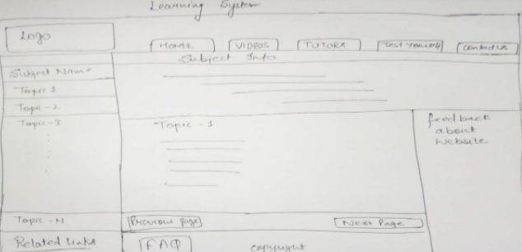

This is the basic layout of the project that we are provided to do. The home page of the website.

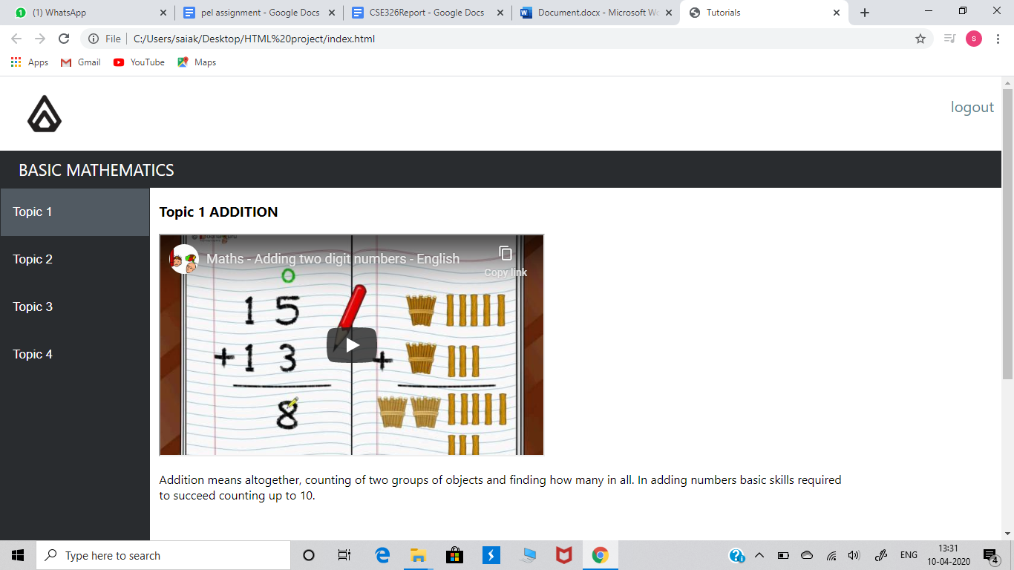

About logo:

The logo is on the top of the left corner which is so different as compared to many logos with something within it. Parent dream something big about their children within themselves. And this website will ensure that they are receiving proper way of teaching. Parent want their children to become professionals and we have chosen this logo as it a perfect example of a professional logo.

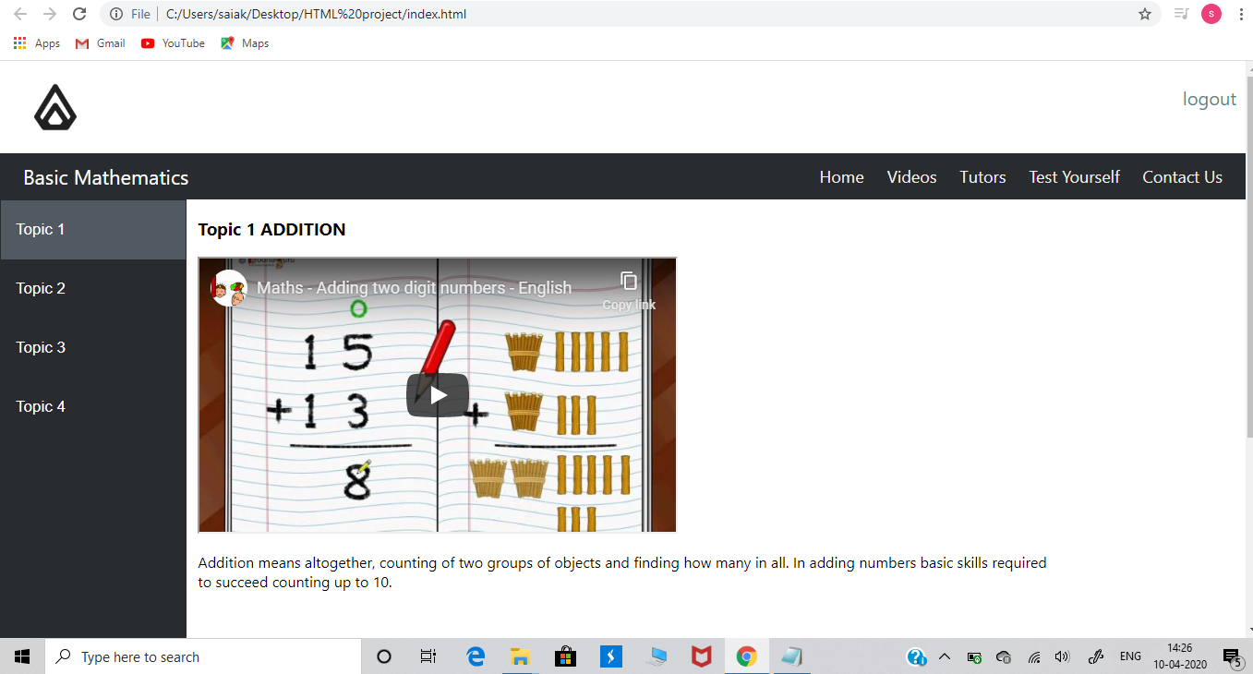

Tags:

There are tags at the top of the right corner of the page like “Home”, “Videos”, “Test yourself” and “Contact us”. These are the tags which provide every information that a customer need. These tags have been developed by using HTML and later on modified in CSS.



This is the Home page of our website. As the student open the page, he will easily get to know what to do next in it as we have designed in such a way that even a small child can operate it without difficulty. This page is also developed by using HTML and styled in CSS.

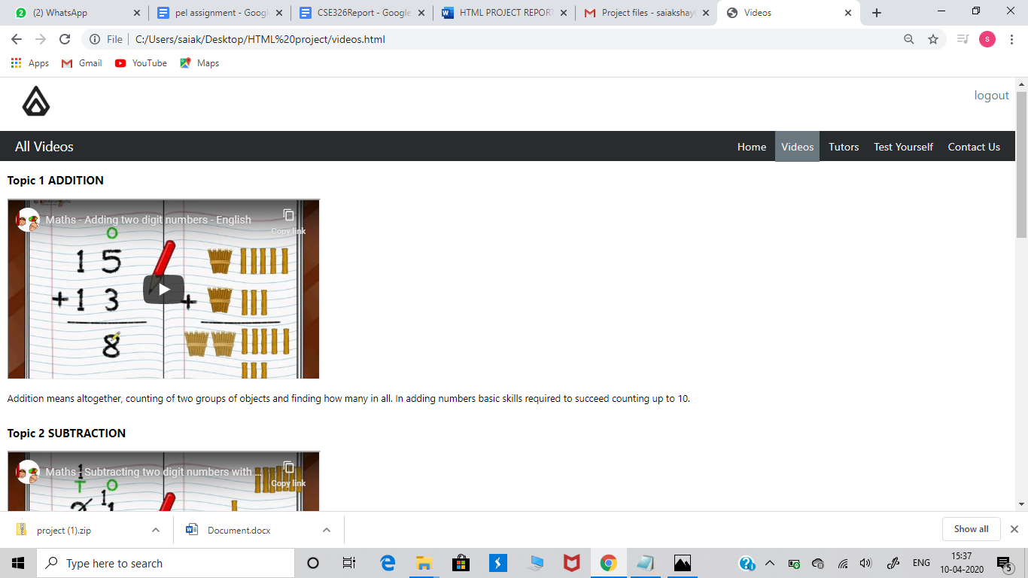

In videos tag if you open it you will be able to view all the videos tutorials present in it. The videos include addition tutorial, subtraction tutorial, multiplication tutorial and division tutorial. And each of the method is explained with definitions. This page is also developed by using HTML and styled in CSS.

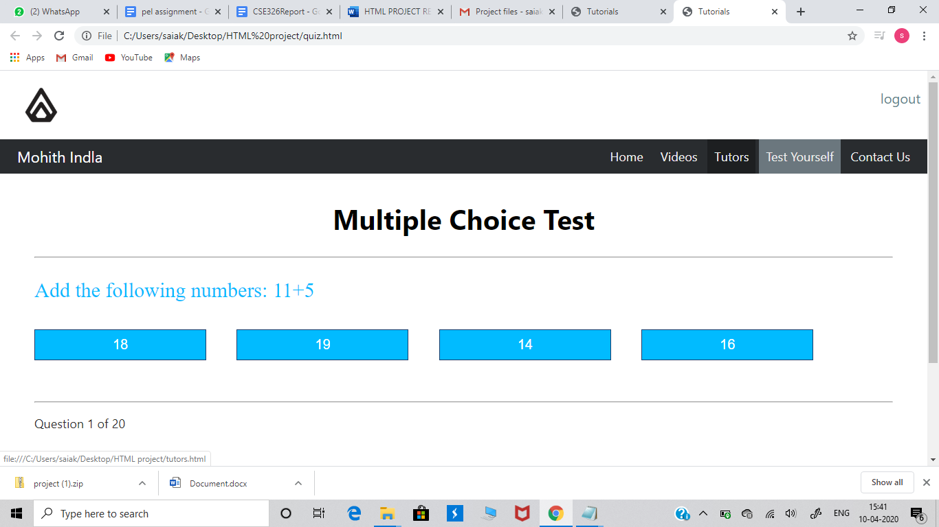

The special feature of our website is test yourself page. As many competitive exams are held across India. The main and common format for these exams is multiple choice questions. And on this basis, we have designed this page as the test taken in this are a multiple choice type. By this, young students will get habituated to the competitive exam which they are going to write in their upcoming standards. This page is developed by using HTML and styled in CSS. And for this page additionally we have also used JAVA script.

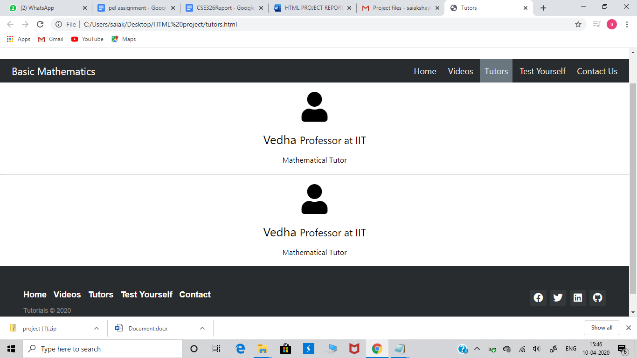

In the tutor tag we have mentioned the information of the tutor. We have made this page using HTML and CSS.

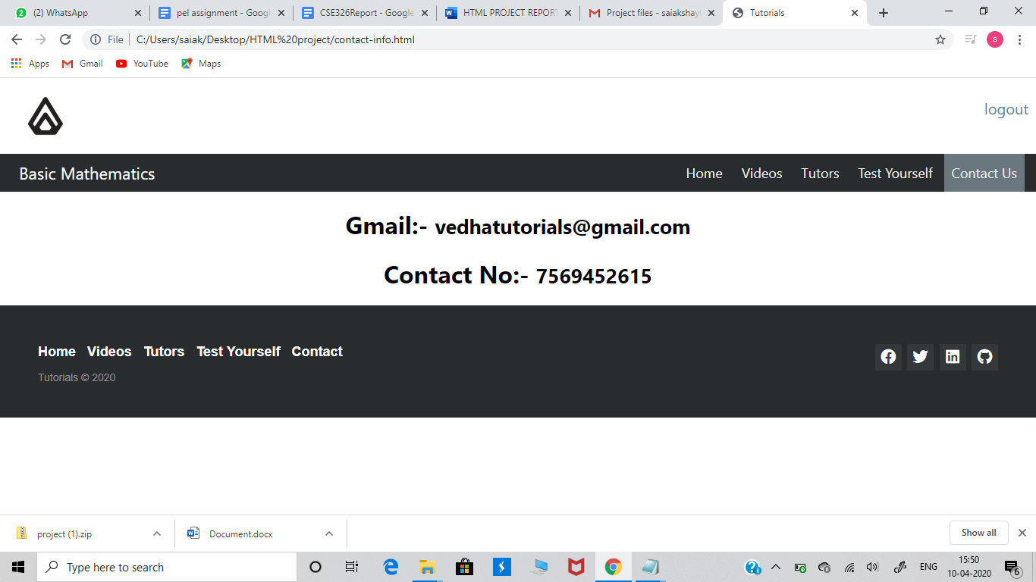

And finally, in the contact us tag we have provided the contact information about us. So that, the viewers can ask or share their personal query about the website.

* THIS IS OUR FINAL REPORT ON THE PROJECT
* THANKYOU